UMD 5a-1 – Post Construction Storm Water Management BMP

Title: Tree Preservation, Protection, and Planting

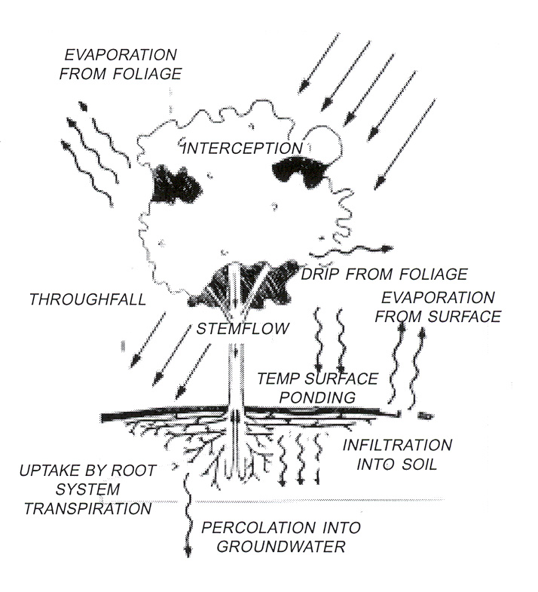
Tree preservation and protection are key components of the UMD Master Plan’s goal of restoring a north woods tree cover at UMD. Besides creating a welcoming image for the campus, trees provide habitat for diverse species of wildlife, improve air quality, lower ozone levels, help cool the campus and provide storm water benefits. Trees affect storm water above ground (interception, evaporation, and absorption), at the surface (temporary storage), and below ground (infiltration, permeation and filtration). For every 5% of tree cover added to a community, storm water is reduced by approximately 2%. The effects of trees on storm water runoff are greatest on sites whose soils are relatively impermeable. A tree’s weekly water needs equal a minimum of 5 gallons plus 5 gallons per caliper inch. A 2 caliper inch tree needs approximately 15 gallons per week. “Caliper inch” refers to the diameter of a tree four and a half (4.5) feet above the ground.
UW-Extension

Tree Preservation and Replacement

Trees within construction sites are subject to the following requirements:

- The landscape designer (or UMD Project Manager) shall develop a “tree preservation plan” showing trees to be protected and those to be removed. UMD Grounds staff shall determine the type, health, and caliper of the trees slated to be removed
- Removal of specimen trees should be avoided. A “specimen tree” is a deciduous tree twelve (12) caliper inches or greater, a coniferous tree whose height is twenty (20) feet or greater, or any size memorial or specially designated tree. If removal is required, they shall be replaced at a ratio of two (2) caliper inches per caliper inch (or feet per foot). For example; a twelve (12) caliper inch tree could be replaced with six (6) four (4) caliper inch trees or twelve (12) two (2) caliper inch trees.
- Removal of trees within 50' of streams, wetlands, or ponds should be avoided.
- Tree preservation through tree moving is permitted. Only trees with a reasonable chance of survival can be moved. UMD Grounds staff or a certified arborist shall determine the survivability of trees slated to be moved.
- Trees should be replaced within the same watershed as those removed. Replacement of trees outside the project site can be accomplished through coordination with UMD Grounds.
- Removal of deciduous trees between four (4) to eight (8) caliper inches; coniferous trees ten (10) to fifteen (15) feet high; or groups of smaller trees which provide a buffer or screening are to be replaced at a ratio of one half (.5) caliper inch per inch (or foot per foot for coniferous trees).
- Removal of deciduous trees eight (8) to twelve (12) caliper inches or coniferous trees fifteen (15) to twenty (20) feet high will be replaced in equivalent total caliper inches (or foot per foot).
- Replacement trees shall be a minimum of one and a half (1.5) inches in diameter if deciduous, or five (5) feet in height if coniferous.
- Trees removed because of natural death, disease, invasive designation or non-construction related safety issues do not need to follow replacement requirements.

Tree Protection

For trees to remain healthy during a construction project they must be protected from construction activities. In addition to the University of Minnesota’s Construction Standards Division 1 01530 2. Tree and Plant Protection, the following requirements apply to all construction sites:

- Trees within the construction zone shall be protected from damage and soil compaction by equipment, debris, and storage intrusion. Suggested materials for protection are concrete barricades, construction fencing or chain link fencing – protection type to be determined by owner representative (UMD project manager) in conjunction with UMD Grounds staff.
- Tree protection shall be placed at a minimum of one and a half (1.5) times (in feet) the caliper dimension (in inches) from the base of the trunk. For example; a ten (10) caliper inch tree would require protection a minimum of fifteen (15) feet from the base of the trunk.
- Trees that are necessarily impacted by construction shall be pruned and root pruned as required by UMD Grounds staff or a certified arborist.

Tree Planting

For the long term health of a tree it must be correctly situated in its environment and must not create a detriment to the safety and maintenance of the campus.
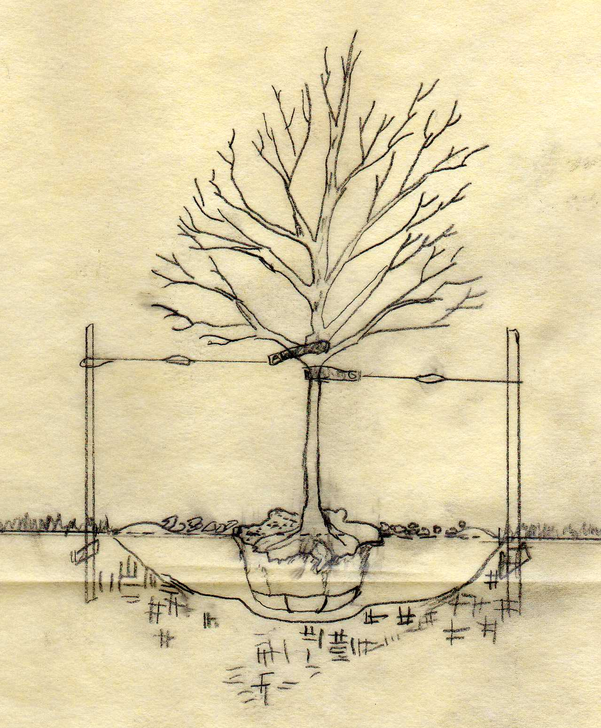
- Climate, topography, soil conditions, and surrounding vegetation should be considered when choosing trees. Native trees are preferred.
- Sites should include a mix of deciduous and coniferous trees.
- The mature size of a tree should be considered when choosing a location. Trees (at maturity) should not touch buildings or obscure signage.
- Replacement trees should be preferentially located such that they provide shade to streams, wetlands, ponds, or impervious surfaces.
- Trees shall be planted so the root collar is located four (4) to six (6) inches above the finished grade. Stock should be examined to establish the location of root collar. Remove any extra soil from around trunk.
- Netting, burlap, twine, etc. shall be removed from the upper one-third (1/3) or more of root ball.
- Tree holes shall be a minimum of three (3) times the width of the root ball or container.
- Sides and bottom of tree hole shall be scarified to encourage root growth into the existing soils. Blend existing and planting soils to refill planting hole.
- Score the outside of soil mass to redirect circling roots when necessary.
- No street tree shall be planted in boulevards less than eight (8) feet wide or closer than twenty (20) feet to any intersection.
- No tree shall be planted closer than ten (10) feet to any fire hydrant.
- No coniferous trees shall be planted such that they would be within five (5) feet of a sidewalk at their mature width.

Responsible Party: Peggy Dahlberg, UMD Facilities Management
Contact: UMD Facilities Management (218) 726-8262 2/27/2009

BMP Notes

Division 1 – General Requirements
University of Minnesota, Facilities Management
November 2002 (Revised: December 2006)
Page 18 of 29

Division 1, Section 01530
2. Tree and Plant Protection
2.1. PROHIBITED: Using trees that are to remain for crane stays, guy anchors or other fastenings.
2.2. PROHIBITED: Lighting fires, storing materials, piling debris or parking motorized equipment within the spread of the branches of any tree.
2.3. PROHIBITED: Placing excavated material against shrubs or tree trunks.
2.4. Specify that trees and shrubs shall be protected from damage unless noted that they shall be removed.
2.5. Specify which trees and shrubs are protected before starting work. Ensure that such trees and shrubs remain protected until work is completed.
2.6. Verify protection requirements with the owner's representative. Indicate protection requirements on the drawings. Specify boxing or fencing as follows:
2.6.1. Install concrete highway traffic barriers around shrubbery and the outer perimeter of low-hanging branches.
2.6.2. Shore and brace trees adjacent to open excavation to maintain soil around the root system. Notify the owner’s representative immediately of damage to crowns or root systems. The contractor shall secure a qualified arborist to remedy damage.
2.6.3. If any tree that is to remain is severely damaged or should die within three years because of contract operations, replace it with the same caliper and species. If a replacement is not available, the contractor shall reimburse the university in an amount equal to $1,000 for each inch of diameter of the lost tree, measured 48 inches above grade. Refer to Program Information/General Requirements, item 6. Site Planning for more information.

Division 2 – Site Work
University of Minnesota, Facilities Management
November 2002 (Revised: December 2006)
Page 5 of 15
02115 - SELECTIVE CLEARING
1. Tree and Plant Protection: Refer to Division 1, Section 01530 - Barriers and Enclosures for tree protection requirements.

2. Tree Removal: The university shall designate which trees and shrubs shall be preserved, transplanted or removed. Coordinate with the owner's representative

http://www.forester.net/sw_0203_trees.html

Garland TX - "If a developer knocks down a tree, he has to replace it by total caliper inches. If he takes down a 10-caliper-inch tree, for example, he has to put in two 5-caliper-inch trees, 10 1-inchers, or whatever totals up to the tree removed.”

How much water can a tree process? Horticulturists note that trees' weekly water needs equal 5 gal. plus 5 gal. per caliper inch. For example, a 2-caliper-inch tree needs 15 gal. (5 + [5 x 2] = 15) weekly. This calculation, of course, is for minimum needs; many trees can take in more water.
"A mature bald cypress can absorb 880 gallons per day, depending on the soil type and saturation," Swenk says, though admits it's extremely difficult to retrofit a neighborhood with tree-based stormwater controls. "Plan for detention and it can be retarded by your design. Plant trees that will help absorb stormwater." He suggests a number of trees that can work for stormwater purposes (Table 2). Most of these species thrive in the Midwest.
Table 2. Recommended Tree Species
American Basswood | Hackberry | Serviceberry
American Elm* | Osage | Orange Silver Maple
Black Cherry | Paw Paw | Swamp White Oak
Black Gum | Persimmon | Sweetgum
Black Walnut | Red Maple | Sycamore
Boxelder | Red or Pin Oak | Tulip Poplar
Green Ash | River Birch | Willow
* Disease-resistant

"Trees provide habitat for diverse species of wildlife; they improve air quality, lower ozone levels, and help cool the city,"

http://www.stormcon.com/sw_0607_how.html

The Natural Resources Conservation Service, historically, and the Center for Watershed Protection, more recently, have deemed forest cover to be the best use of land for water storage, recharge, runoff reduction, pollutant reduction, and habitat. Tom Schuler, director of watershed research and practice for the center, sees percent forest cover—rather than impervious surface—as a leading indicator of watershed health.

Local governments are increasingly looking toward non-built stormwater management strategies, including trees, to reduce the cost of constructing stormwater control infrastructure.

“incorporating green infrastructure into stormwater management plans” / “incentives for development certification programs like LEED”

http://www.treetrust.org/pdfs/citytrees-bonestroopilot.pdf

http://www.hort.wisc.edu/mastergardener/Spec%20Training/TREES%20AND%20THEIR%20ROLE%20IN%20STORM%20WATER%20MANAGEMENT.PPT.

Mindy Habecker Dane County UW-Extension

For every 5% of tree cover added to a community, storm water is reduced by approximately 2%

How Do Trees Effect Stormwater?
- Above ground effects:
  - Interception, evaporation and absorption of precipitation
- Ground surface effects:
  - Temporary storage
- Below ground effects:
  - Infiltration, permeation and filtration

Trees and Storm Water: Conclusions
- Effects are greatest on sites whose soils are relatively impermeable

Maple-Grove MN
http://www.ci.maple-grove.mn.us/arbor/tzone.htm
it shall be unlawful for any person to remove from privately owned land any tree or trees eight (8) inches Diameter Breast Height (DBH) or larger in excess of the rate of thirty-two (32) inches DBH per acre in any calendar year without immediately replacing any such tree or trees pursuant to the appropriate ratio set forth in Subd. 5
The builder shall be required to replace trees removed form within the building pad on a basis of 1/2 inch DBH of replacement for each inch DBH of removal. If trees are removed from the area outside the building pad, they shall be replaced on the following basis:
Specimen Trunk Size Replacement Criteria
8" - 11" DBH 1-1/2" of trees shall be replaced for every 1" DBH removed
>11" DBH 2" of trees shall be replaced for every 1" DBH removed.
Any replanting shall be done with trees of the primary species of the affected forest. At planting, the trunks of deciduous tress shall be at least two and one-half inches (2-1/2) in diameter as measured six (6) inches above the ground. Coniferous trees shall be at least five (5) feet in height.

A TREE ORDINANCE FOR THE CITY OF HOUSTON, MINNESOTA
http://houston.govoffice.com/index.asp?Type=B_BASIC&SEC={FB3CD534-6472-4A49-BCFC-B91A6A73D45E}
Distance from Curb and Side walk – Te distance trees may be planted from curbs or curblines and sidewalk will be in accordance with the tree species size classes listed in Section V. of this ordinance, and no trees may be planted closer to any curb or sidewalk than the following: small trees, 2 feet; medium trees, 3 feet; and large trees, 4 feet.
Distance from Corners, Fire Hydrants and Driveways – No street tree shall be planted closer than 30 feet to any intersecting curbs or curblines. No street tree shall be planted closer than 10 feet to any fire hydrant, nor 5 feet from any driveway or walkway.

Eagan allows 25% of the existing significant trees to be removed without replacement
Minnetonka – “/” DHB for deciduous / ‘/’ height for coniferous
Tree 1.25” – 3” DBH Balled / 3-6” spade deciduous
Tree 6’-8’ balled / 8’-14’ spade coniferous
Arden Hills
If the tree survey indicates that more than 10 percent of the significant trees on the lot are to be impacted by the project, the applicant will be required to also submit a Tree Preservation Plan. A tree is considered significant when it is healthy, structurally sound, and important to the site or the neighborhood and it meets certain size standards. Generally speaking, the size standards are:
deciduous hard wood trees over 10 caliper inches
deciduous soft wood trees over 12 caliper inches
single evergreens over 15 feet tall
groups of trees which provide a buffer or screening
In general, for every two caliper inches of trees lost (above the 10 percent threshold), one caliper inch of trees must be planted. “Caliper inch” refers to the diameter of a tree 4.5 feet above the ground.

Shakopee
http://www.ci.shakopee.mn.us/pages/Parks/NaturalResources/TreeManagementRegulations.pdf
Tree means a living specimen of a woody plant species that is either a deciduous
tree whose diameter is six (6) inches or greater at DBH, or a coniferous tree whose
height is twelve (12) feet or greater.

Replacement Remove:Replace 1:1 – 4:1

Blane
Replacement trees shall be a minimum of 2-1/2 inch in diameter if deciduous, or 6 feet in height if coniferous
* A significant tree is defined as any live healthy tree measuring 8 inches in diameter or greater, measured a 4.5 feet above the ground.

Here's a U of MN Extension Salt Tolerance chart for common MN trees; may be helpful in the future. http://www.extension.umn.edu/distribution/naturalresources/DD1413.html#Trees

Here's a link to the Int'l Society of Arborists Tree Ordinance section on parking lot shade trees; lots of good stuff on promoting shading of parkinglots; typically 50% canopy cover after 15 years. It's aggressive, but is this something we could look into doing, at least for new parking? http://www.isa-arbor.com/publications/tree-ord/ordprt2c.aspx

Pollen allergens in MN :
http://www.pollenlibrary.com/botany_researchers_maps.php?view=local.php&state=Minnesota&county=St+Louis&season=Winter&filter=significant
http://www.allergyfree-gardening.com/articles.php?archive=2002

